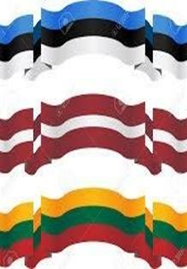 |  | Baltic Film Series  Organized by the  Baltic Arts Council of the Northwest  October 18  at the Seattle Latvian Center  11710 – 3rd Ave. NE Seattle. WA  Showtime: 7:00 p. m.
With the upcoming celebration of the 100th anniversary of independence of Estonia, Latvia, and Lithuania in 2018, the Baltic Arts Council of the Northwest has been created to celebrate the arts and culture of these countries.

The first film of the series will be the 2016 Latvian film,
“Es esmu šeit”, English title “Mellow Mud”, in Latvian with English subtitles. Estonian and Lithuanian films to follow.

A contemporary coming-of-age drama from Latvia, Mellow Mud is an intimate and lyrical character study of an adolescent girl who,
after the death of her grandmother, is thrust into adulthood. She must shoulder raising her younger brother, avoiding a nosy social worker, and navigating a relationship with her English teacher, all in hopes of finding her estranged mother.

Awards: Berlin International Film Festival 2016 (Crystal Bear - Generation 14plus - Best Feature Film); Palm Springs International Film Festival 2017 (New Voices/New Visions Special Jury Prize.

Free admission, donations welcome

