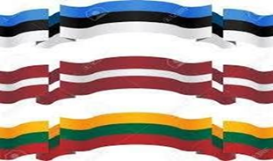  Baltic Film Series  organized by the  Baltic Arts Council of the Northwest  November 9, 2017  Seattle Latvian Center  11710 – 3rd Ave. NE Seattle. WA  Showtime: 7:00 p. m.  Free admission, donations welcome |  | 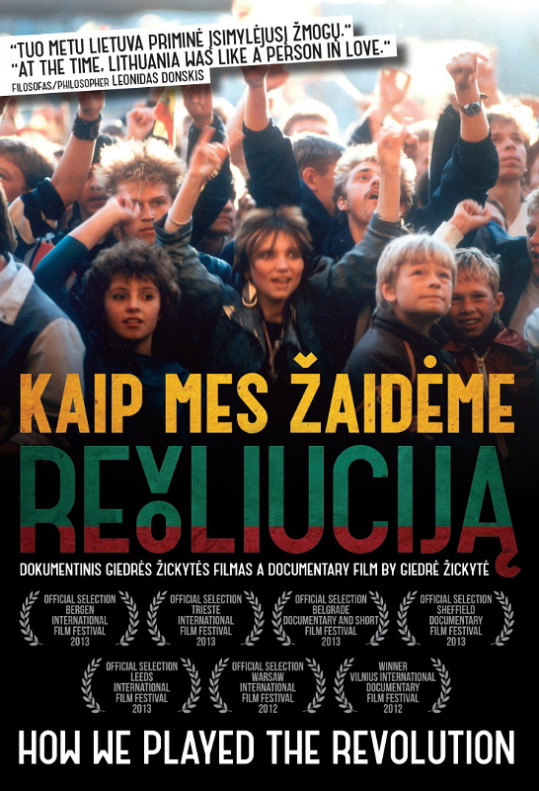
With the upcoming celebration of the 100th anniversary of independence of Estonia, Latvia, and Lithuania in 2018, the Baltic Arts Council of the Northwest has been created to celebrate the arts and culture of these countries.

The second film in our film series is the Lithuanian 2012 documentary, “How We Played the Revolution” with English subtitles.

“This film about the legendary band, Antis, [Duck] shows how youthful determination, energy and bravery, together with a strong , razor sharp, persuasive word and a song woke up Lithuania from its stagnation.
It is inspiring even today.” Dalia Grybauskaite www.facebook.com/D.Grybauskaite

